 |  |  |  |  |  |  | 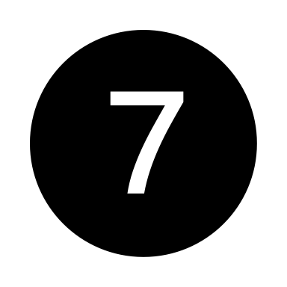
Episode: | Creation: A Good World Begins | Moral Freedom Misused: Brokenness Begins | A People of Promise | Kings, Poets and Prophets | God Came – In Person | God Faced the Worst for Us – and Triumphed | A People of Mission | Re-Creation: God’s Good World Restored
Key Characters: | God  Adam  Eve | God  Adam  Eve  Cain  Abel  Noah | Abraham  Isaac  Jacob  Joseph  Moses | Samuel  Saul  David  Solomon  Ruth  Naomi  Esther  Rahab  Ezekiel  Daniel  Isaiah  Jeremiah  Amos  Malachi | Jesus  Mary  Joseph  Disciples (12+)  Many others | Caiaphas  Pilate  Disciples  Mary Magdalene  Peter  John | Disciples  Holy Spirit  Peter  Paul  Other NT writers | God  Christian Community
Key Ideas: | “Good”  Image of God  Purpose  Paradise | Freedom  Rebellion  Shame  Blame  Expelled  Protected | Promise of Restoration  Blessing  Sacrificial System – Worship  Law  Promise Land | Warning  Struggle  Faithfulness  Hope | Incarnation  Miracles  Teachings  Parables  Prayers | Arrest  Trial  Crucifixion  Death  Resurrection  Abundant Life  Kingdom | Witness  Pentecost  Church  Missionary Movements  Wait | Presence  Paradise Restored  Hope Realized
Key Scriptures: | Gen 1:10, 12, 18, 21, 25  Gen 1:26-27  Gen 1:28-31  Gen 2:15 | Gen 3:1-13  Gen 3: 23-25  Gen 4:8  Gen 6:11-12  Gen 11 | Gen 12:1-3  Gen 32, 33  Exodus 3  Exodus 20  Exodus 36 | I Samuel 9:21-25,  10:6-16  Amos 8-9  Malachi 3:1 | Phil 2:1-11  John 1:1-14  Mark 2, 5  Matthew 5-7  Matthew 6  Luke 4:14-21 | Matthew 26-28  Mark 14-16  Luke 22-24  John 18-20 | Acts 1:8  Acts 2:1-41  Acts 2:42-47  Acts 4:32-35  Acts 8  Acts 9 | Revelation 21:1-8  Revelation 22:1-6

